**GRADING SYSTEM**

**PROJECT DOCUMENTATION**

**By**

**Navarro, Mae Kylla**

**Saylo, Jerlen Chesil**

**Sim, Marie Antonette**

In compliance for the subject IT Elective 3, our group decided to make a Grading System to have an immersive experience in doing *ReactJS*. The Computerized Grading System is an application used at universities to handle records and past records of students in an easier and secure way. The features given by our subject professor were divided into four categories – **login and registration, user roles management, approval management and student management.** This documentation will serve as a gateway to the progress our group has made into developing the grading system.

**Login & Registration – 05/30/2022**

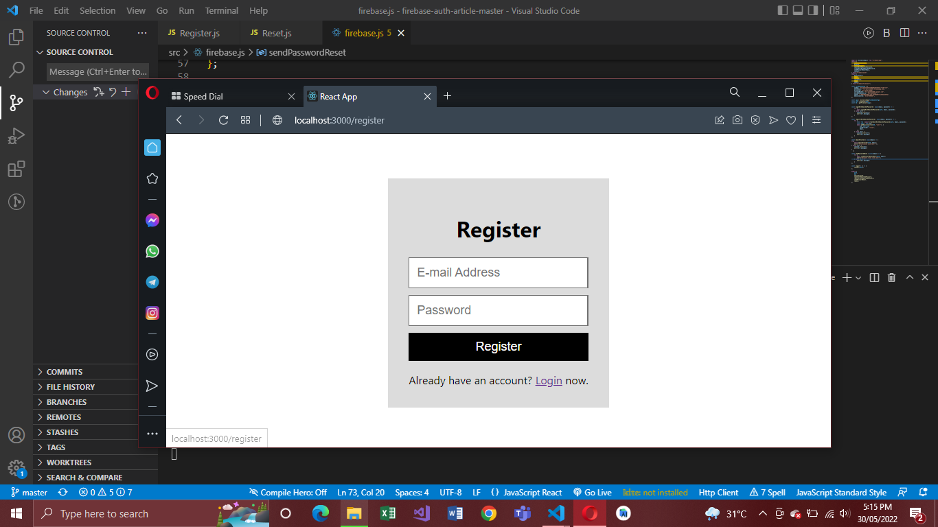**1.0 Registration**

**1.1 Forgot Password**

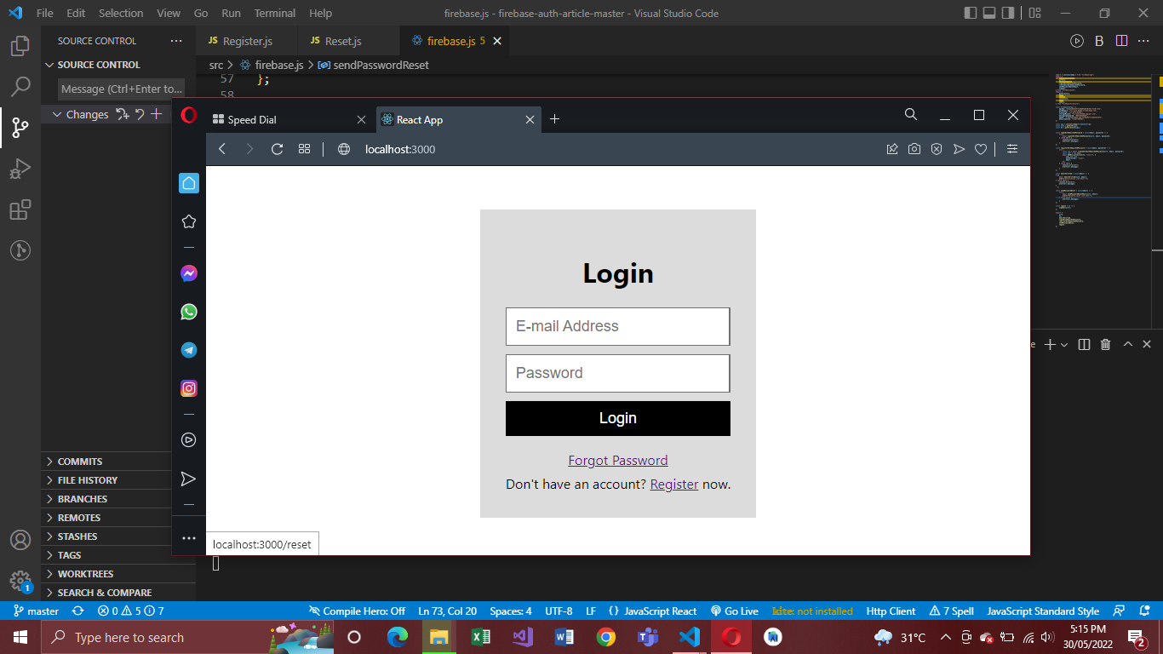

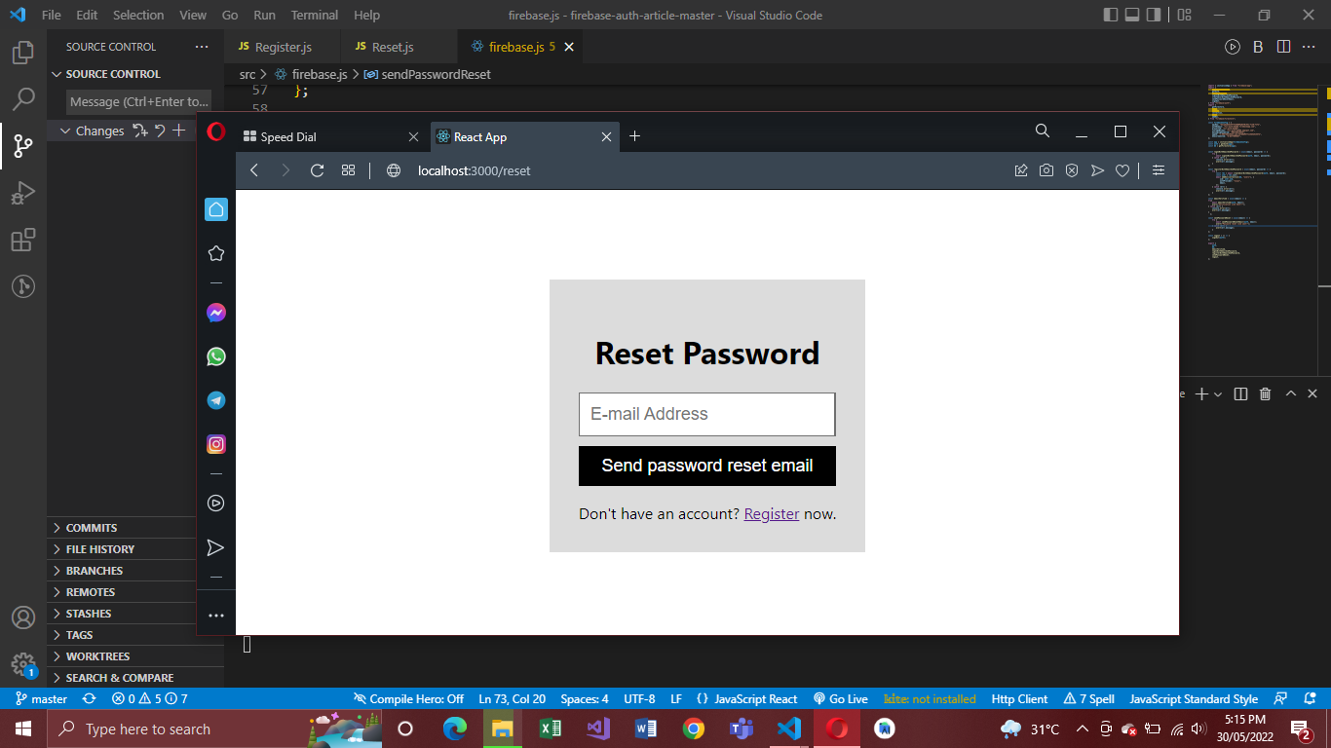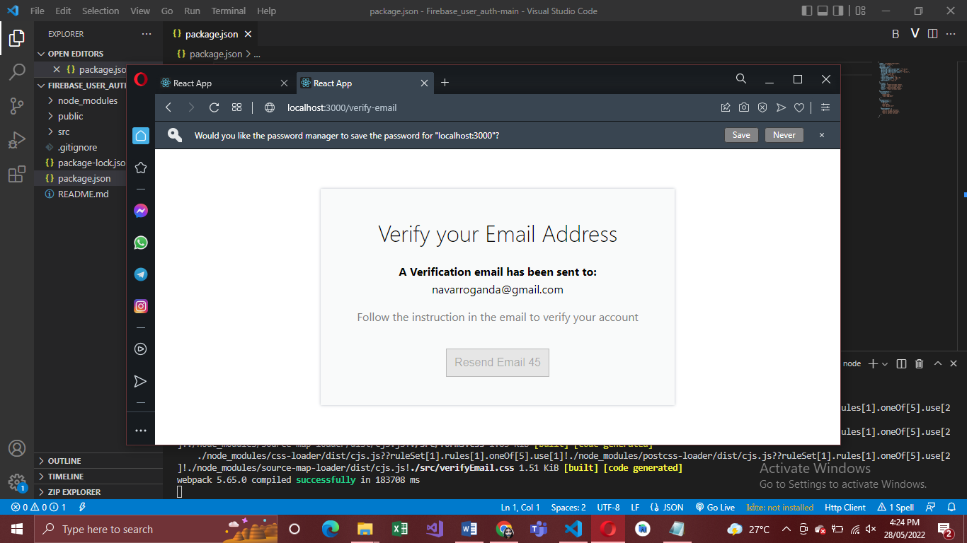**1.2 Change Password**

**1.3. Login**



**User Roles Management**

**2.0 Roles Creation**

**2.1 Assign Roles**

**2.2 Default User Role**

**Approval Management**

**3.0 Assign Approvers**

**3.1 Approver List**

**Student Management**

**4.0 Add Student**

**4.1 Updating Stud. Info**

**4.2 Removing Stud.**

**4.3 View Stud. List**